Oman J Ophthalmol. 2012 Sep-Dec; 5(3): 171–174.
doi: 10.4103/0974-620X.106101
PMCID: PMC3574513

Transcanalicular laser dacryocystorhinostomy using low energy 810 nm diode laser
Sanjiv K. Gupta, Ajai Kumar,¹ Swati Agarwal, and Paritosh Pandey²
Department of Ophthalmology, King George's Medical University, Lucknow, Uttar Pradesh, India
¹DOMS, Jan Kalyan Eye Hospital, Lucknow, Uttar Pradesh, India
²Manas ENT Center, Lucknow, Uttar Pradesh, India
Correspondence: Dr. Sanjiv Kumar Gupta, 18/464, Indira Nagar, Lucknow - 226 010, Uttar Pradesh, India. E-mail: sanjiv204@gmail.com
Copyright : © 2012 Gupta SK, et al.
This is an open-access article distributed under the terms of the Creative Commons Attribution License, which permits unrestricted use, distribution, and reproduction in any medium, provided the original author and source are credited.

Abstract

Background:
Hypertrophic scarring may be a cause of failure after transcanalicular laser dacryocystorhinostomy (DCR) surgery. This hypertrophic scarring results from tissue charring and excessive coagulation, which may be caused by the high laser energy. We have evaluated the use of low energy settings to prevent hypertrophic scarring, for a successful outcome.

Aims:
To perform and evaluate transcanalicular laser DCR using low energy 810 nm diode laser.

Design:
Interventional, non-comparative, case series.

Materials and Methods:
Patients with nasolacrimal duct obstruction and chronic dacryocystitis, who needed DCR, and were fit for surgery under local anesthesia, were recruited to undergo transcanalicular laser DCR using a 810 nm diode laser. The outcome was measured by the patency of the lacrimal passage, as indicated by the relief in the symptoms and the patency on syringing at the last follow-up. The surgical time and surgical complications were noted.

Statistical Analysis Used:
Descriptive analysis.

Results:
The study included 94 patients. The average age was 30.1 years (range 15 - 69 years). Seventy (74.4%) patients were female. Eight patients had failed external DCR. Per-operative patency of the passage was obtained in all the patients. Average surgical time was seven minutes (5 – 18 minutes). At the end of the study period of one year, a successful outcome was seen in 85 patients (90.5%). There were eight patients of previous failed DCR surgeries, and six of them achieved a cure at the end of follow-up.

Conclusions:
Transcanalicular Laser DCR can be safely performed using a low power 810 nm diode laser. The surgery is elegant, minimally invasive, allows fast rehabilitation, and has an excellent success rate.
Keywords: Chronic dacryocystitis, diode laser, dacryocystorhinostomy, transcanalicular DCR, 810 nm diode laser

Introduction
Laser-assisted Dacryocystorhinostomy (DCR) (transcanalicular or endonasal) is a better alternative to the standard external DCR, because it avoids the disadvantages associated with external DCR and has the advantage of making the procedure simple and fast with comparable success rates.[1–7]
Literature describes the use of various lasers[1–8] for performing transcanalicular laser DCR. Here we have described the use of an 810 nm diode laser for the same. The 810 nm diode laser has the energy and wavelength characteristics that specifically target soft tissues. It has an affinity for hemoglobin and melanin, which are the components that provide color or pigmentation to the tissue; because of these properties, it is more efficient and better equipped to address deeper soft tissue problems.[9,10]
The 810 nm diode laser is already used in ophthalmology for different retinal diseases,[11–16] laser trabeculoplasty,[17] transpupillary thermotherapy for melanoma,[18] retinoblastoma, and wet Age-Related Macular Degeneration (ARMD). The multiple applications of this laser make it a cost-effective solution for these disorders. At present, with its use in DCR surgery, it saves the additional expense of buying another laser (980 nm diode laser) for the procedure and brings down the cost of this minimal invasive surgery for needy patients.
The light energy released by the diode laser transforms into heat, resulting in the vaporization of cells, a process referred to as the photothermal effect. The degree to which the tissue absorbs this energy depends on its affinity to the laser's wavelength, the clinician-selected energy output, the duration of exposure, and the characteristics of the targeted tissue.[19] The absorbed energy increases the temperature of the targeted tissue immediately, resulting in a sequence of tissue reactions (e.g., warming and welding to coagulation, protein denaturalization, vaporization, drying, and carbonization depending on the amount of heat used). High quanta of energy directed at a small area, within a small duration of time, increases the local tissue temperature to undesirable levels and this causes tissue charring and collateral tissue damage. These factors promote hypertrophic scarring and fibrosis resulting in a small ostia size and eventual closure of the ostia created. With lower energy settings, (less than 3 watts)[20] while keeping other parameters the same, will result in lower collateral damage and lower incidence of tissue charring. Keeping this hypothesis we have attempted to use lower energy settings to perform the same surgery to prevent overheating of the tissue and charring, which may cause hypertrophic scarring, as reported by Guillermo Plaza et al.[1]
This study was proposed to study the use of an 810 nm diode laser at low energy settings for performing Transcanalicular DCR in patients with chronic dacryocystitis, and to study the outcome during the follow-up period of one year.

Materials and Methods
Patients suffering with epiphora due to nasolacrimal duct blockage and who presented to our Outpatient Department (OPD) between February 2006 and May 2007, were evaluated and screened. These patients underwent ear, nose, and throat (ENT) evaluation prior to surgery. Patients having canalicular block, lid pathology or nasal pathology contributing to the epiphora were excluded. Nasolacrimal duct (NLD) blockage was confirmed by syringing. Informed consents were obtained from all the patients after explaining the surgical procedures and offering them an option of external DCR surgery. Patients who opted for transcanalicular DCR were included in the study. All procedures were conducted under local anesthesia.
The patient's periorbital skin was painted with 5% Povidone iodine and draped. Few drops of 4% lignocaine were instilled topically in the operating eye before surgery. Four percent lignocaine solution was sprayed into the ipsilateral nasal cavity. Lignocaine 2% with adrenalin (Xylocaine, Astra Zeneca) was injected to block the infratrochlear and the infraorbital nerves supplying the relevant anatomical area.
The patient was asked to open the eye. The lower and upper puncta were then dilated with the Netteleship punctum dilator. With the help of a 24G cannula inserted into the lacrimal sac through the canaliculi the proximal lacrimal passage was flushed with 2% lignocaine, to anesthetize the canaliculi and the sac. Both the canaliculi were dilated using lacrimal probes, such that a 20G cannula could be easily passed through the canaliculi up to the medial sac wall lying on the lacrimal bone, which could be felt as a ‘hard stop’. A Standard 20 endo laser probe connected to an 810 nm Diode Laser, with a maximum power delivery of 3 watts (APPASAMY Associates, India; used for laser delivery during vitrectomy) was inserted through the lower punctum, keeping in mind the normal anatomy of the lower canaliculus, and passed further till the probe touched the medial sac wall lying on the lacrimal bone (felt as the ‘hard stop’). Laser settings used in the study had a power of 2 Watts, duration of one second, and pulse interval according to the surgeon's convenience, ranging from 0.2 to 0.5 seconds. The laser was fired with the probe tip pressed against the bone. Once the laser energy created an opening through the lacrimal sac, lacrimal bone and nasal mucosa, the sudden advancement of the probe into the middle meatus could be felt by the operating surgeon. A nasal endoscope (0 degree Hopkins telescope) was used to visualize the opening from the nasal cavity, to confirm the success of the procedure. Too much linear pressure might fracture the thin lacrimal bone, and as result instead of an ostium a self-sealing opening may result, thus a deliberate attempt was made not to press too hard on the bone and allow the laser to make a track itself with coagulation of the tissue, (rather than fracturing the thin bone). A wider aperture in the tissue was obtained in this manner. The procedure was repeated by repositioning the tip till five to six such ‘punctures’ were made. These subsequent punctures were actually just the enlargement of the first ostium as seen by the nasal endoscope. Patency of the lacrimal passage was confirmed by syringing immediately after a satisfactory opening was made. The eye was patched after application of the antibiotic steroid eye ointment.
Systemic oral antibiotic and oral anti-inflammatory medications were administered for five days. The eye patch was removed after 12 hours. Steam inhalation twice daily was commenced following the procedure. Nasal decongestant drops, hydrocortisone 0.02%, naphazoline nit. 0.025% (EFCORLIN NASAL® [drops], GSK), ofloxacin 0.3% w/v, and prednisolone acetate 1% eye drops (EXOPRED® eye drops, Allergan India), four times a day, for a period of four weeks, were prescribed. Daily syringing of the lacrimal passage was done for a week with Ringer lactate solution, to dislodge any blood clot /mucous plug. Thereafter, the patients were called for evaluation and syringing at two-week, four-week, and 12-week intervals, following surgery. After these visits, the patients were scheduled for three monthly reviews over a period of one year. At every visit, the patients were asked about their symptoms, in terms of epiphora and discharge. The patients underwent syringing and they were questioned about their ability to taste the bitter taste of the antibiotic eye drop in the throat. After the initial follow-up period of three months, syringing of the passage was done only if the patients’ symptoms suggested confirmation of passage patency.
Patients in whom the patency of the passage was not maintained during the follow-up period, underwent nasal endoscopy, to rule out any local pathology, and if absent, underwent repeat laser DCR.

Results
The study included 94 patients who satisfied the inclusion and exclusion criteria. Age of the patient ranged from 15 to 69 years, with a mean age of 30.1 years. Seventy patients were female and 24 were male. Forty-five procedures were on the right side and 49 on the left side.
Forty-eight (51.0%) cases had only watering from the eye as a symptom, 37 (39.36%) complained of additional purulent discharge, and nine (9.57%) presented with swelling at the medial aspect of the eye, with watering. The duration of symptoms ranged from one year to eighteen years, with a mean duration of 7.6 years. Sixteen patients had a past history of syringing and probing for partial block of a lacrimal passage, and eight had failed external DCR.
Patency of the passage was obtained in all the patients during the surgical procedure and confirmed by free passage of syringing fluid into the nasal cavity, with an endoscopic view. Average surgical time was 7 minutes (range 5 - 18 minutes). The patients who presented with mucocele (n = 9) (9.57%) had resolution of the swelling as well.
In four (4.25%) patients the symptoms recurred and the syringing was blocked after a period of 4 - 15 days following the primary procedure. Out of these four patients, two were patients with failed external DCR surgery. Nasal endoscopy was done to explore the status of the nasal opening of the fistula. In all the patients there was a membranous growth seen at the site of the ostea, which could be seen as a depression on the lateral nasal wall [Figure 1]. The procedure was repeated and patency of the passage was achieved on the table. This time a larger opening was attempted. The aforementioned procedure of syringing every day for a week, was re-initiated after the repeat procedure. Syringing of the passage was done with 0.5 ml of injection dexamethasone (2 mg/ml), with 4.5 ml Ringer lactate solution. This was done keeping in mind the aggressive healing response, as seen in the previous procedure. The use of steroid was to suppress the healing so that the fistula remained patent.
At the end of study period all the patients were patent on syringing. Nine patients (~9.5%) complained of discharge or watering during periods of nasal congestion (during the upper respiratory tract inflammation), which responded to decongestant nasal drops and oral ambroxol hydrochloride 30 mg (Mucolite SR). The four patients with early failure were among these nine patients with partial success. These patients were given the option of open DCR, which they refused. At the end of three months the nasal ostia were photographed via nasal endoscope, to visualize the opening of the fistula created [Figure 2].

Discussion
In this era of minimally invasive surgery (MIS), it is the need of the hour to have DCR surgery also cross the incision barrier and embark as a ‘no incision’ surgery. This has been achieved by the introduction of the 980 nm diode laser, which has been designed for use in laser DCR surgery. The 810 nm and 980 nm lasers are both diode-based, so they are cost-effective and durable. However, the 810 nm diode laser can prove to be more cost-effective due to its multiple applications in ophthalmology and other medical branches.[11–18]
A previous study using an 810 nm diode laser, with a power setting of 5 - 12 watts, with silicon tube intubation, for a period of three months, reported a success rate of 88% (total number of cases 25) after the primary procedure.[1] In our study the success rate for primary surgery was 95.77% (90 patients). The success rate after the second additional procedure was 100% (94 patients), if patency on syringing was considered to be the success parameter. However, nine patients (9.5%) had partial relief from epiphora at the end of the study. These patients had small openings on nasal endoscopy and were compromised during the episodes of nasal congestion, causing functional failure.
Studies using other lasers for a similar procedure have reported a success rate ranging from 75 to 94% with the first procedure and better with an additional second procedure.[1–8] In our series we have seen a success rate of 95% with the primary procedure, without intubation. The improved success rate seen in our study may be attributed to the use of low power (2 watts), as compared to the other studies (5 - 12 watts). High energy can cause tissue heating and charring, which could promote hypertrophic scarring and resultant shrinkage of the final ostea, or adhesion to the surrounding structures.[1]
We recommend performing transcanalicular laser DCR using an 810 nm diode laser. The use of low power settings for the laser procedure achieves a larger fistula opening due to fewer adhesions and scarring, and it has a 95% success rate as a primary procedure.

Footnotes
Source of Support: None
Conflict of Interest: No.

References
1. Plaza G, Beteré F, Nogueira A. Transcanalicular Dacryocystorhinostomy With Diode Laser: Long-term Results. Ophthalmic Plast Reconstr Surg. 2007;23:179–82.
2. Narioka J, Ohashi Y. Transcanalicular-endonasal semiconductor diode laser-assisted revision surgery for failed external dacryocystorhinostomy. Am J Ophthalmol. 2008;146:60–8. [PubMed: 18439559]
3. Alañón Fernández MA, Alañón Fernández FJ, Martínez Fernández A, Cárdenas Lara M, Rodríguez Domínguez R, Ballesteros Navarro JM. Endonasal and endocanalicular dacryocystorhinostomy by diode laser; Preliminary Results. Acta Otorrinolaringol Esp. 2004;55:171–6. [PubMed: 15359663]
4. Alañón Fernández FJ, Alañón Fernández MA, Martínez Fernández A, Cárdenas Lara M. Transcanalicular dacryocystorhinostomy technique using diode laser. Arch Soc Esp Oftalmol. 2004;79:325–30. [PubMed: 15286901]
5. Caversaccio M, Frenz M, Schär P, Häusler R. Endonasal and transcanalicular Er:YAG laser dacryocystorhinostomy. Rhinology. 2001;39:28–32. [PubMed: 11340692]
6. Woo KI, Moon SH, Kim YD. Transcanalicular laser-assisted revision of failed dacryocystorhinostomy. Ophthalmic Surg Lasers. 1998;29:451–5. [PubMed: 9640564]
7. Piaton JM, Limon S, Ounnas N, Keller P. Transcanalicular endodacryocystorhinostomy using Neodymium:YAG laser. J Fr Ophtalmol. 1994;17:555–67. [PubMed: 7822692]
8. Dalez D, Lemagne JM. Bull Soc Belge. Transcanalicular dacryocystorhinostomy by pulse Holmium-YAG laser. Bull Soc Belge Ophtalmol. 1996;263:139–40. [PubMed: 9410404]
9. Miyasaki MA. Shedding light on the soft tissue laser. Signature. 2004;11:11–3.
10. Patino MG, Neiders ME, Andreana S, Noble B, Cohen RE. Collagen. An overview. Implant Dent. 2002;11:280–5. [PubMed: 12271567]
11. Sivaprasad S, Sandhu R, Tandon A, Sayed-Ahmed K, McHugh DA. Subthreshold micropulse diode laser photocoagulation for clinically significant diabetic macular oedema: A three-year follow up. Clin Experiment Ophthalmol. 2007;35:640–4. [PubMed: 17894684]
12. Desmettre TJ, Mordon SR, Buzawa DM, Mainster MA. Micropulse and continuous wave diode retinal photocoagulation: Visible and subvisible lesion parameters. Br J Ophthalmol. 2006;90:709–12. [PMCID: PMC1860243] [PubMed: 16531424]
13. Jain S, Newsom RS, McHugh JD. Treatment of retinal breaks with large-spot diode laser photocoagulation. Ophthalmic Surg Lasers Imaging. 2005;36:514–7. [PubMed: 16355959]
14. Hussain N, Hussain A, Natarajan S. Indocyanine green dye enhanced laser photocoagulation for juxtafoveal choroidal neovascularisation. Indian J Ophthalmol. 2005;53:183–6. [PubMed: 16137963]
15. Astasheva IB, Sidorenko EI, Aksenova II. Laser coagulation in the treatment of different-type retinopathy of prematures. Vestn Oftalmol. 2005;121:31–4. [PubMed: 15881154]
16. Squirrell DM, Stewart AW, Joondeph BC, Danesh-Meyer HV, McGhee CN, Donaldson ML. Large-spot subthreshold infrared laser to treat diabetic macular edema. Retina. 2008;28:615–21. [PubMed: 18398365]
17. Detry-Morel M, Muschart F, Pourjavan S. Bull Soc Belge. Micropulse diode laser (810 nm) versus argon laser trabeculoplasty in the treatment of open-angle glaucoma: Comparative short-term safety and efficacy. Bull Soc Belge Ophtalmol. 2008;308:21–8. [PubMed: 18700451]
18. Cajigal-Morales C, Valverde-Almohalla S, Encinas-Martín JL. Transpupillary thermotherapy in the primary management of choroidal melanoma. Arch Soc Esp Oftalmol. 2005;80:171–8. [PubMed: 15803428]
19. Rossmann JA, Cobb CM. Lasers in periodontal therapy. Periodontol. 1995:150–64.
20. Evolution of diode laser. [Last accessed on 2012 Oct 05]. Available from: http://www.denlase.com/article/2011102513321129479.pdf .

Figures and Tables

Figure 1
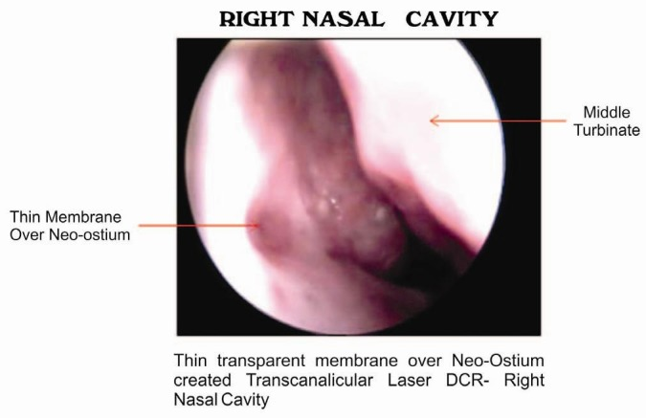
Nasal endoscopic view in a patient with closure of the DCR ostium due to membranous growth

Figure 2
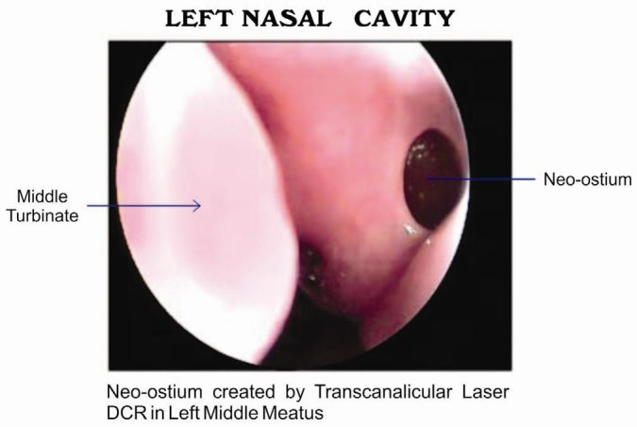
Nasal endoscopic view in a patient after successful transcanalicular DCR, after three months of surgery

